Cognizant Java FSE – (Deep Skilling)

(WEEK-5)

**MODULE 1:** Microservices with Spring Boot 3 and

Spring Cloud

**Submitted by**  
**Name:** SOLLETI VENKATA KUSUMA  
**Roll No:** 111522102145  
**Email:** [22102145@rmd.ac.in](mailto:22102145@rmd.ac.in)

**College:** RMD ENGINEERING COLLEGE  
**Batch:** Java FSE – 2026

**SuperSet Id:**6394672

**Creating Microservices for account and loan**

In this hands on exercises, we will create two microservices for a bank. One microservice for handing accounts and one for handling loans. Each microservice will be a specific independent Spring RESTful Webservice maven project having it's own pom.xml. The only difference is that, instead of having both account and loan as a single application, it is split into two different applications. These webservices will be a simple service without any backend connectivity.

Files are to be created in D drive where I have created a folder with my superset Id and then created a folder named microservices inside it and this the path where we have to create two microservices for account and loan.

PROJECT STRUCTURE:

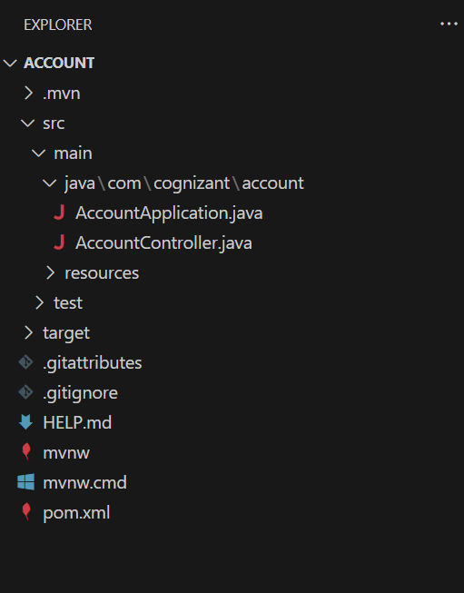

**Generate Spring Boot project from Spring Initializr**

1. Open [Spring Initializr](https://start.spring.io/).
2. Fill in:
   * **Group:** com.cognizant
   * **Artifact:** account
3. Select **Dependencies:**
   * Developer Tools > Spring Boot DevTools
   * Web > Spring Web
4. Click **Generate** to download the account.zip.

Extract the account folder from the zip into:

D:\6394672\microservices\

**In** D:\6394672\microservices\account\src\main\java\com\cognizant\account\AccountController.java

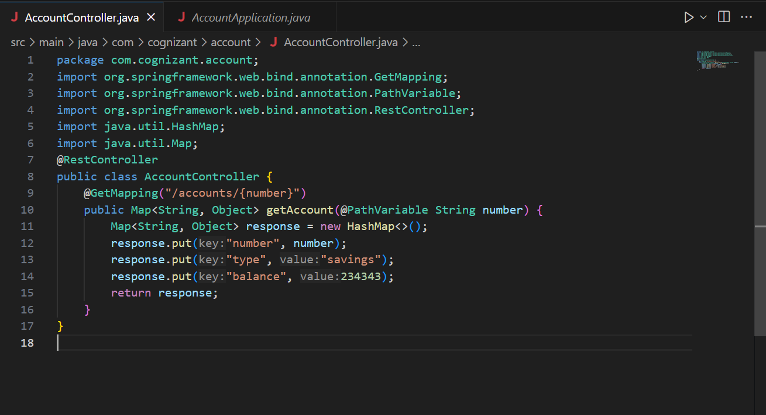

In D:\6394672\microservices\account\src\main\java\com\cognizant\account\AccountApplication.java

Run AccountApplication.java

Go to <http://localhost:8080/accounts/00987987973432>

**Generate Spring Boot project from Spring Initializr**

1. Open [Spring Initializr](https://start.spring.io/).
2. Fill in:
   * **Group:** com.cognizant
   * **Artifact:** loan
3. Select **Dependencies:**
   * Developer Tools > Spring Boot DevTools
   * Web > Spring Web
4. Click **Generate** to download the loan.zip.

Exctract Zip into D:\6394672\microservices\

In D:\6394672\microservices\loan\src\main\java\com\cognizant\loan\LoanController.java

In D:\6394672\microservices\loan\src\main\java\com\cognizant\loan\LoanApplication.java

Run LoanApplication.java

Go to <http://localhost:8081/loans/H00987987972342>

